Article Overview
Each workstation that accesses an OpenInsight application requires several libraries and supporting MSI packages to be installed. This article presents several methods to prepare new workstations using the ClientSetup.exe program provided in the OpenInsight directory.

OpenInsight should be installed and shared from a network folder before following the guidelines listed. If you have not already installed OpenInsight please refer to the installation instructions and then return here to setup additional workstations.

Method 1: Manual Installation
Small networks without an active directory domain controller should use this method. It is the easiest option and requires no scripting or silent installations. Simply log into the workstation with administrative rights and launch the ClientSetup.exe that is located in the same directory where you installed OpenInsight. All of the libraries will be installed and any errors during installation will be immediately visible. This is the preferred method for debugging any silent or push installations in the methods below.

Method 2: Silent Installation From Script
Automating the manual installation process will reduce time spent setting up new workstations and prevent inconsistent workstation configurations. If your organization's workstations are setup by hand this method will help automate the setup process.

To begin, determine the ClientSetup.exe silent install arguments for your environment. From a command prompt change to your OpenInsight directory and execute "ClientSetup.exe /?" to display the command line arguments for silent installation. See image blow:

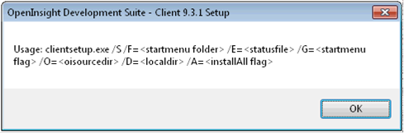

Tip! The the order of the command line arguments should be consistent with the usage example above. Some arguments can be omitted but do not alter the placement order in the parameter string. For argument values with long file names or spaces do not quote the values.

Description of arguments:
/S | Silent installation flag. If omitted a normal installation will launch.
/F | Name of start menu folder for shortcuts. Creation of folder can be overridden with the /G argument. Argument is optional. Default value is "OpenInsight Development Suite - Client" if not specified.
/E | Path and file name to write the result of the silent install. File will be created if it doesn't exist. Useful for debugging failed silent installs. If omitted no status will be recorded.
/G | Boolean argument. Enables or disables creation of the start menu group with the name specified in the /F flag. Default is to create start menu items.
/O | Path to folder where oinsight.exe is located. The setup assumes the working directory is wereOpenInsight is installed. This setting is required if ClientSetup.exe is not launched from theOpenInsight directory or the current working directory cannot be set.
/D | Path to local directory on client where the setup will install required components. Default path if not specified is "C:\Revsoft\OIClient"

Command prompt examples:

Install from the OpenInsight directory using all default values.
clientsetup.exe /S

Install from UNC path.
"\\server1\Revsoft\OpenInsight\clientsetup.exe" /S /O=\\server1\Revsoft\OpenInsight

Install from the OpenInsight directory and suppress start menu.
clientsetup.exe /S /G=0

Install from UNC path with all command line arguments specified - no defaults.
"\\server1\Revsoft\OpenInsight\clientsetup.exe" /S /F=My OI Application /E=C:\revsoft\ci_result.txt /G=1 /O=\\server1\Revsoft\OpenInsight /D=C:\Revsoft\OI Client

Method 3: Silent Installation Pushed from Server
For any size network with a properly configured Active Directory server the recommended method for deploying ClientSetup.exe is pushing it out from the server. This involves using the silent installation concepts in the last method. To accomplish the push installation a free 3rd party utility called PDQ Deploy is required. If your organization already has a preferred method for pushing installations to clients you can adapt these directions but for the sake of discussion these directions assume there isn't an existing deployment tool.

Before proceeding please download and install PDQ Deploy on your server or administration workstation. When installed the utility will resemble the image below.

Using the PDQ Deploy tool is a two part process. First, the installer is created to define what actions and parameters should be passed to the ClientSetup.exe file. Second, the target workstations are selected for deployment.

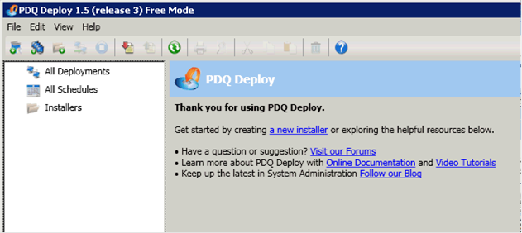

Creating the First Installer
1. From the PDQ Deploy tool click File -> New Installer
2.
3. In the 'Installer Name' field type ClientSetup
4.
5. In the 'Installer File' field enter the UNC path to ClientSetup.exe
6.
7. Choose the 'Parameters' field and type the silent installation parameters that apply to your installation. In our example the parameters string is:
8.
9. /S /E=\\queen.lab.winwinsol.int\testclientlogs\%COMPUTERNAME%.txt /G=0 /O="\\queen.lab.winwinsol.int\RevSoft\OpenInsight" /D=C:\Revsoft\OIClient
10.
11. All of the parameters except /S and /O are options. Please refer to the silent installation method for a description of each command line parameter.
12.
13. Tip! The /E parameter instructs the installer to write a log with the installation results. By specifying the log file as a public share on the server and using the %COMPUTERNAME% windows environment variable all of the log files for the installation can be saved in one folder for easy access.
14.
15. Verify your screen resembles the image below and click OK when completed.
16. 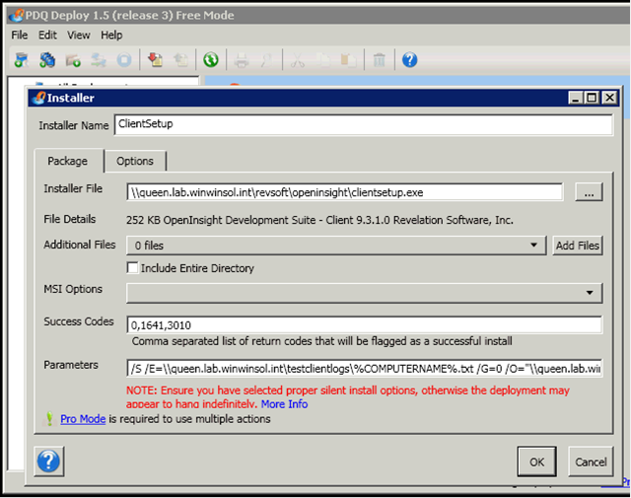

Now you have a defined installation. You can run this installation against any existing computer on your network or any new computers that you join to the network. The next step is to select which computers to deploy to and monitor the results.

Selecting Deployment Targets
1. Select 'ClientSetup' from the menu tree and click "Deploy Now".
2.
3. A window will appear for you to enter the computer names that the deployment should be pushed to. Enter the computer names or click 'Import' to select a list of computers from the Active Directory or other source.
4. 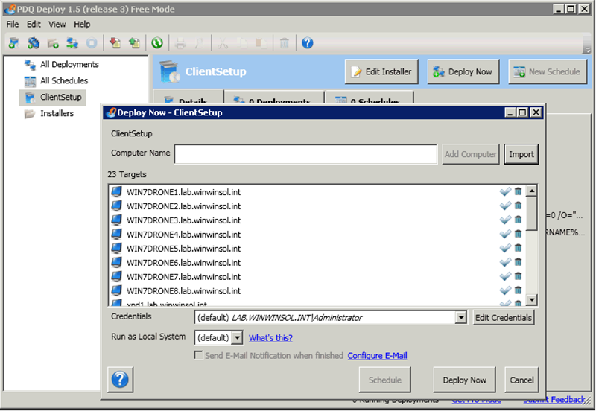
5.
6. When all of the computer names have been entered click 'Deploy Now' to start the installation.

As the installation starts the display will update with information to indicate whether the deployment failed or was successful. The image below indicates that 4 of the 23 computers failed the deployment. The error status for each computer should be checked. Any errors relating to connections to the workstation should be fixed before proceeding. Common errors result from permissions connecting to the workstation or the ADMIN$ share being unavailable. Use the Diagnose link to use the PDQ Deploy tool to try and resolve the error.

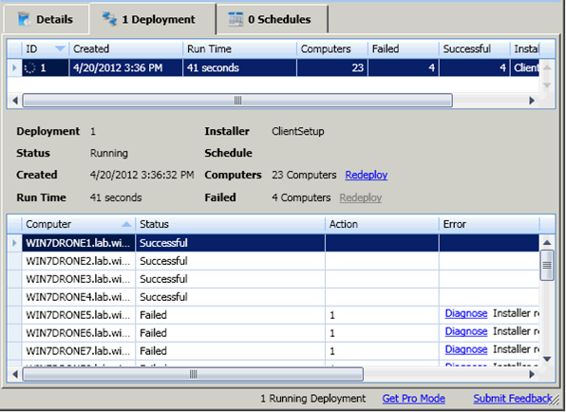

Any errors unrelated to connections to the workstation are likely a result of errors with the installer parameters or missing prerequisites. To examine why these computers failed check the log folder that was specified in the deployment parameters. According to the log file for the failed workstation one of the MSI packages failed to install. The best way to troubleshoot a failed installation is to run the ClientSetup.exe manually and check for errors OR to examine the Windows Event log on the workstation.

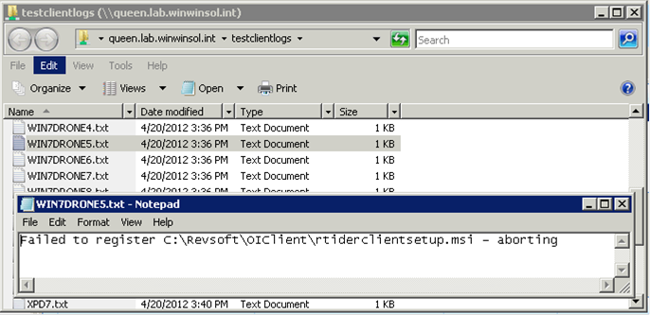

When you have resolved any dependency issues the PDQ Deploy tool's "Redeploy" link can re-start the installation on the failed computers.

After PDQ Deploy reports the installation was successful on all workstation the log file share can be checked to verify the success of individual workstations or by checking the "Programs and Features" list on the target computer. The image below shows the OpenInsight ClientSetup components on one of the target workstations.

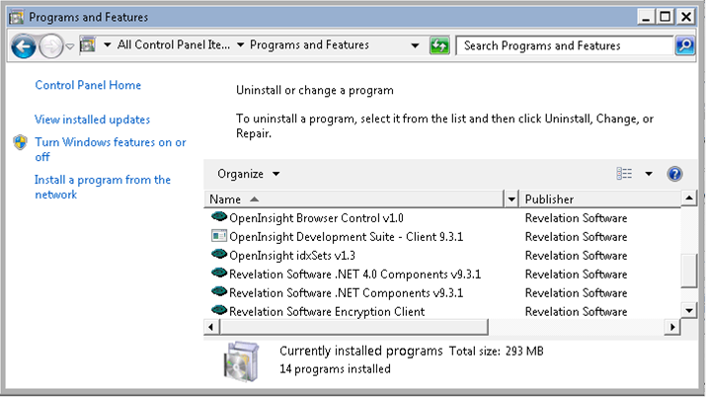

This completes the ClientSetup process. Using the PDQ Deploy tool makes it easy to deploy the ClientSetup program to new workstations as they are added to the network.

