Installing API layer

Install SRP HTTP Framework and setup API Server settings
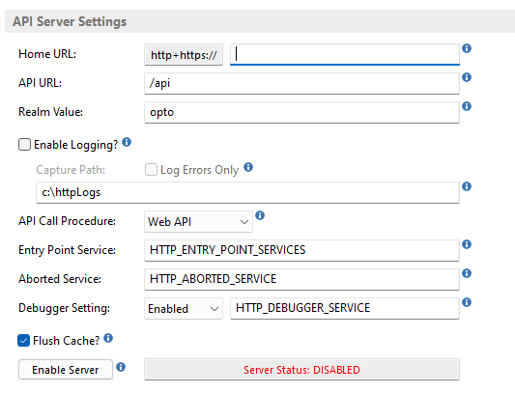

Software install
- 32-bit Java must be installed (If there is no Oracle Java license to utilise then the latest free Adopt OpenJDK with Hotspot for Windows x86 )
- IIS (Internet Information Service) must be installed.
- CGI extensions must be enabled for IIS
- IIS Rewrite Rules install https://www.iis.net/downloads/microsoft/url-rewrite
- Ensure Chrome is installed and Default (NOT IE)

Configure IIS (directory can be different. Just be consistent & update rewrite rules)
- Copy x32 OECGI4.exe (v4.0.1.0) to C:\inetpub\cgi-bin
- Add an ISAPI and CGI restriction. Path = “c:\inetpub\cgi-bin\OECGI4.exe”. Description = “OECGI4”. Allow Extension Path to execute needs to be checked
- Open Handler Mappings and make sure CGI-exe is enabled
- Add a Virtual Directory against the Default Website. Alias = ‘cgi-bin’. Path = “c:\inetpub\cgi-bin”
- Add URL rewrite rules for API URL (e.g. /api above) web.config looks like:
<?xml version="1.0" encoding="UTF-8"?>
<configuration>
<system.webServer>
<httpErrors existingResponse="PassThrough" />

<!--Entries for WebApp CORS-->
<httpProtocol>
<customHeaders>
<add name="Access-Control-Allow-Methods" value="GET,PUT,POST,PATCH,DELETE,OPTIONS" />
<add name="Access-Control-Allow-Headers" value="*,Content-Type" />
</customHeaders>
</httpProtocol>

<!--Rewrite Rules-->
<rewrite>
<rules>

<!--API rewrite for API endpoint-->
<rule name="Root API" stopProcessing="true">
<match url="^api$" />
<conditions logicalGrouping="MatchAll" trackAllCaptures="false" />
<action type="Rewrite" url="cgi-bin/oecgi4.exe" />
</rule>
<rule name="API" stopProcessing="true">
<match url="^api([_0-9a-z-/.]+)$" />
<conditions logicalGrouping="MatchAll" trackAllCaptures="false" />
<action type="Rewrite" url="cgi-bin/oecgi4.exe/{R:1}" />
</rule>

</rules>
</rewrite>

</system.webServer>
</configuration>

Setup Data Service
- Import registry %OI_HOME%\oecgi4_WOW6432.reg. Make sure that the User/Password and ApplicationName are setup correctly and it is matching %OI_HOME %\eserver.cfg for the ServerPort first! Make sure the REG file is SRP Compliant (HTTP_AUTHORIZATION and PROCEDURENAME have changed from back in theday)

[HKEY_LOCAL_MACHINE\SOFTWARE\Wow6432Node\RevSoft\OECGI4]
"AdditionalValues"="HTTP_AUTHORIZATION,HTTP_X_AUTHORIZATION,HTTP_DEBUG,HTTP_MEDIA_TYPE,HTTP_ACCEPT_ENCODING,HTTP_ACCEPT_CHARSET,HTTP_ACCEPT_LANGUAGE"
"ApplicationName"="xxx"
"EngineName"=""
"FileMode"="1"
"FilePath"=""
"OILocation"=""
"ProcedureName"="HTTP_MCP"
"ServerPort"="6088"
"ServerURL"="localhost"
"ShutdownFlags"="1"
"StartupFlags"="1"
"SysDownPage"=""
"UserName"="xxx"
"UserPassword"="xx"
"WorkingDirectory"=""

- run file %OPTOPROG%\OEServer\InstallApp-NT.bat as Admin. Make sure % OI_HOME %\OEServer\conf\wrapper.conf has the correct descriptive Engine labels first. This will create a service OEngine that needs to be started the first time in Window’s Services

Test install
NOTE: INET_TRACE does not work with SRP HTTP_MCP

SRP HTTP Framework – add /version endpoint to non Authenticated path
Test version endpoint in Postman (If on server, baseurl can simply be ServerIP/api or 127.0.0.1/api or localhost/api)
